**The Responsibility Assignment Matrix (RAM)**

Projects can involve large numbers of people often from different departments, functions and divisions of the business. The project manager is accountable for the project but this does not mean they are solely responsible for all the work involved. A Responsibility Matrix is used to define who in the organization is responsible for individual work elements and deliverables. By forming a matrix with the work breakdown structure and the organizational breakdown structure, responsibilities can be assigned to employees in form of tasks. Each task is assigned a WBS and OBS code, the department responsible, the person responsible, and the scope of work required.

**EXAMPLE OF A RESPONSIBILITY ASSIGNMENT MATRIX (RAM)**  
**(RACI CHART)**

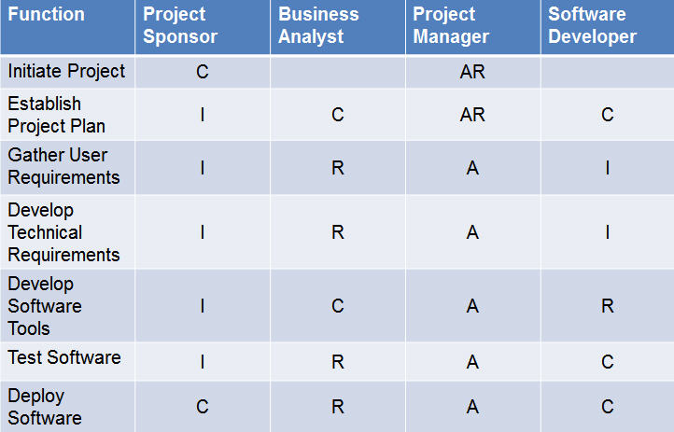

**R –** Responsible

**A –** Accountable

**C –** Consult

**I –** Inform

### What is the Responsibility Assignment Matrix?

So you've constructed your [work breakdown structure (WBS)](http://www.brighthubpm.com/templates-forms/2645-what-is-a-work-breakdown-structure/) and your [organizational breakdown structure (OBS)](http://www.brighthubpm.com/project-planning/11639-how-and-when-to-use-an-obs/). You have a schedule tentatively made. What's missing? Perhaps you should create a responsibility assignment matrix as well.The responsibility assignment matrix links activities to [resources](http://www.brighthubpm.com/resource-management/14438-key-elements-of-resource-management/). It makes sure that every task is completed by someone. The matrix itself is a chart you can create using Microsoft Excel listing human resources across the top and activities down the left-hand side. The matrix can be as simple as placing a check mark under the resources name for a particular task, or it can get more complicated, indicating precisely which role any given resource has in completing the task.

### Why Should you Use a Responsibility Assignment Matrix?

I already mentioned the benefit of knowing exactly whom is responsible for what when using a responsibility assignment matrix. This, while the main reason for creating this beneficial chart, isn't the only reason you might want to create it. By creating a responsibility assignment matrix, you can quickly see whether you have enough resources to complete the project in the time allotted. You can also avoid confusion - especially if you use the roles listed below - over who is assigned to do what when. This prevents Joe from saying "But I thought it was assigned to Mary." Finally, when trying to gain funding for your project, you can paint a realistic picture for perspective investors by showing exactly how many resources are required to finish the project.

### How do you Create Responsibility Assignment Matrix?

The first step in creating a responsibility assignment matrix is to [decompose your project](http://www.brighthubpm.com/resource-management/15314-decomposing-your-projects/) and create a work breakdown structure. Once you have completed this important first step, you will know what the project deliverables will be. If you compose an organizational breakdown structure - breaking the project down into a hierarchy of departments, it will facilitate the process of assigning deliverables to responsible parties. Creating this second chart is an option that is highly recommended.

Once you have the list of deliverables, open an Excel file. Down the left-hand side list each deliverable. If there were intermediate deliverables discovered in the process of creating the work breakdown structure, list those as well.

After listing each deliverable down the side, list each resource across the top of the table.

Now, you will assign deliverables to resources using the following code for roles:

**R:** Responsible - this is the resource that owns the work. Each deliverable should have at least one person responsible for it.

**A:** Accountable - this is the person who approves the work. There is only one accountable resource.

**C:** Consulted - this is the person who delivers information required to complete the work.

**I:** Informed: This is the person who is informed of the progress of the deliverable.

**S:** Supportive: This is the person who provides work in addition to the responsible party.

**V:** Verifies: This is the person who ensures that the work meets standards.

**F:** Final Authority: This person gives the final stamp on the completed work.

In assigning roles, you will use at least the first four listed above RACI. Assign each deliverable to at least one responsible party. Assign each deliverable exactly one accountable party. Continue until everything has been assigned. Distribute the responsibility assignment matrix monist the staff and make explicit your expectations for each of them.

### How to make the RACI work better?

1. Make sure that every task has at least one person assigned for “R” and “A” roles. In some cases both the roles might be taken by the same person (if the task is simple and non-critical).
2. Make sure that every task has only one person assigned as “A”. Though responsibilities can be shared, accountabilities have to be fixed to a single person.
3. If there are too many people in the “C” category, figure out if all of them need to be in the loop. Consider moving some of them to the “I” category. Also keep the “I” category to a minimum to reduce the noise in communication.

In summary, RACI matrix is a great project management tool that greatly improves the communication within the team and helps getting the tasks done faster. If used right it would reduce the amount of email noise (getting emails for tasks that you don’t need to be informed of) and helps the whole team to stay productive.

